Title: Basic geospatial analysis techniques

What you will learn to:
- Reproject a layer.
- Filter layers and select features using SQL expressions.
- Understand how to use the dissolve, buffer, and clip processing algorithms.
- Label features.

Resources:
- Data for this exercise is in the data5 folder (UNZIP the folder after downloading).

Laboratory Exercise:
In this exercise, you will explore some of the basic analysis tools available in QGIS to conduct a spatial analysis for a team of surveyors visiting the National Geodetic Survey Monuments in Albuquerque, NM. You will create a map showing monuments within the Albuquerque city limits. The surveyors will use this map to plan their fieldwork for the work.

You will utilize four basic geospatial analysis techniques to process the data and produce the final map needed by the surveyors:
- Selection uses set and Boolean algebra to select records of interest.
- Buffer is the definition of a region that is less than or equal to a distance from one or more features.
- Clip defines the spatial extent to which features will be output based on a “clipping” (or mask) polygon.
- Dissolve combines similar features within a data layer on an attribute.

In this exercise, you will use four vector layers (i.e., shapefiles):
- Bern.shp – monuments in Bernalillo County, NM
- jurisdiction.shp – city boundaries
- roadInventory.shp – road network
- tl_2010_35001_tract10 – contains the census tracts that show the subdivision of a county.

Deliverables:
- Map of Monuments within the Albuquerque city

Procedure:

NOTE: Create a folder and call it lab5 where you will save the maps that you produce during processing.

Part 1 – Querying and extracting subsets of data

1.1 Working with coordinate reference systems
1. Open QGIS
2. On the Browser panel, select the four layers and drag them to the map canvas. Say “OK” to accept the default transformation settings (Figure 1).

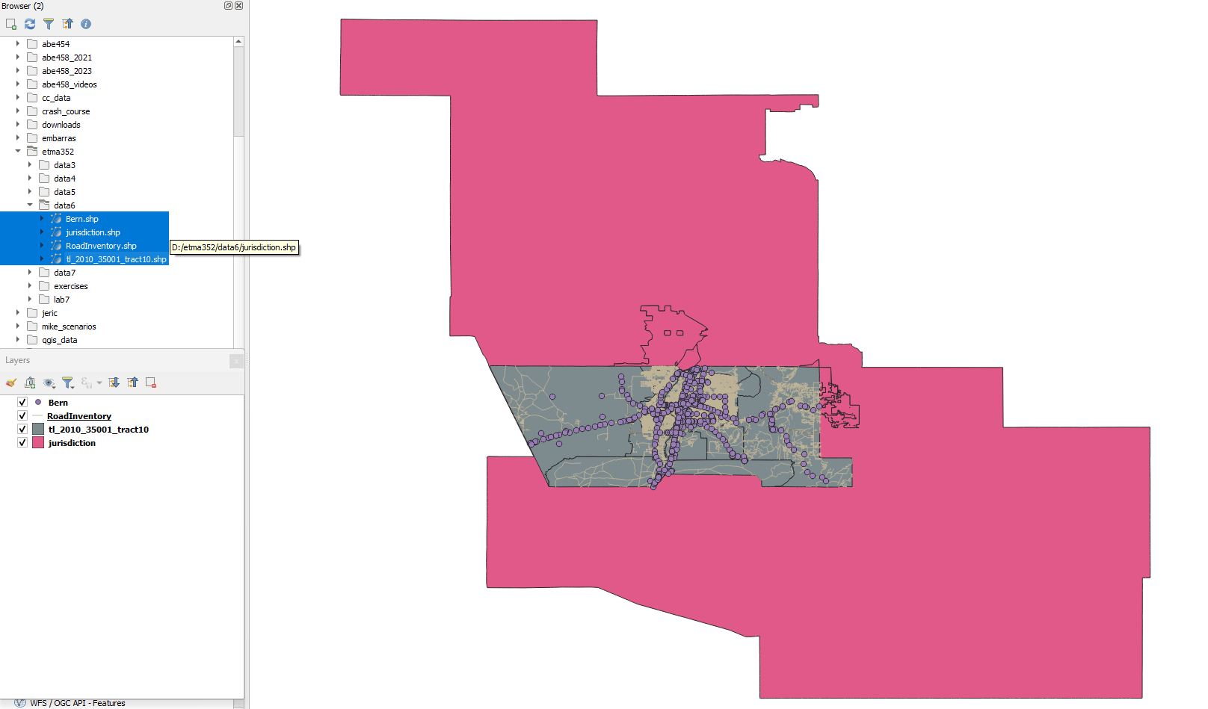
Figure 1. Adding the layers to the map canvas
3. Re-arrange the layers in the Layers panel so that the Bern layer is on top, followed by the RoadInvetory, tl_2010_35001_tract10, and jurisdiction (Figure 1).

4. Save your project as lab5.

5. Check the projection of the layers. On the Layers panel, hover the mouse on each layer and note that the Bern and the tl_2010_35001_tract10 layers are on EPSG:4326 (i.e., EPSG: 4326 – WGS 84) CRS while the jurisdiction and RoadInventory layers are on EPSG:2903 (i.e., EPSG:2903 – NAD(HARN)/New Mexico Central (ftUS). To see the full details of the CRS, right-click on the layer, choose Properties then Information.

6. We will use the EPSG:2903 – NAD(HARN)/New Mexico Central(ftUS) CRS for this exercise. On the Layers panel right-click on the RoadInventory layer and choose Layer CRS – Set Project CRS from layer.

The project is now in EPSG:2903 - NAD(HARN)/New Mexico Central(ftUS) projection. This means that the Census Tracts and the monuments were projected on the fly into EPSG:2903. Projecting on the fly is fine for cartographic purposes but not for geospatial analysis. Since we will be performing geospatial analysis, the data layers should be in the same CRS. Hence our first task is to put all the layers into the same CRS.

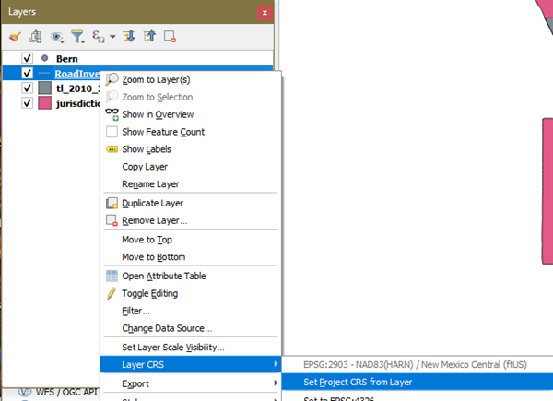
Figure 2. Setting the project CRS on the fly

7. Right-click on the Bern layer in the Layers panel and choose Export – Save Features As. This will open the Save Vector Layer as … window where you will specify the following (Figure 3):
- Format: GeoPackage (default). NOTE: A GeoPackage is a handy database container to store all the derived project layers.
- File name: Click the Browse button and navigate to your lab5 folder and name the file Bern_County
- Layer name: Monuments
- CRS: Click the Browse button for the CRS. The Coordinate Reference System Selector window will open. From the Recently Used Coordinate Reference Systems choose EPSG:2903 - NAD(HARN)/New Mexico Central(ftUS)
- Leave the rest as default.
- Make sure the Add saved file to map option is checked.
- OK
- You no longer need the original Bern layer in your map and can remove it. Right-click on the original Bern and choose Remove Layer. Click OK on the Remove layers and groups window to confirm.

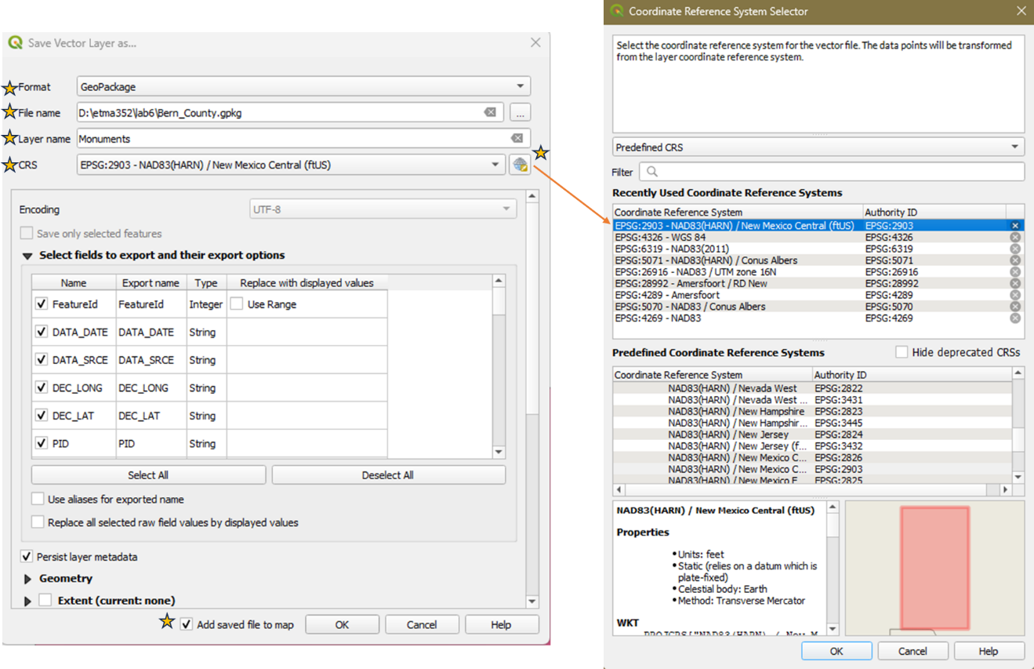
Figure 3. Reprojecting the Bern layer into a GeoPackage
8. Repeat the above steps (#7) to export the tl_2010_35001_tract10 layer into EPSG:2903.
- Format: GeoPackage (default)
- File name: Click the Browse button and navigate to your lab5 folder and click Bern_County.gpkg. You will save it in the same GeoPackage
- Layer name: Census Tracts
- CRS: EPSG:2903 - NAD(HARN)/New Mexico Central(ftUS)
- Leave the rest as default.
- Make sure the Add saved file to map option is checked.
- OK
- Remove the original tl_2010_35001_tract10 layer from the Layers panel.

NOTE: In the Layers panel the Monument and Census Tracts layers will appear with Bern_County- as a prefix pointing to the name of the GeoPackage they are part of.

9. Save your project!

1.2 – Dissolving Tract Boundaries into County boundary

For the map, you will need a polygon that represents the county boundary. The Census Tracts collectively define the county, so you will use the dissolve tool to create a county boundary from the Census Tract. This will merge adjacent polygons in the layer into a single polygon which is the county boundary. For example, if you have counties in the United States, you could dissolve them based on the State name and create state boundary layers.

1. First check the setting to ensure that the layers you generate from processing algorithms are added to the Layers panel with their output file name.
- From the main menu choose Settings – Options then choose the Processing tab. Expand the General setting and make sure that the Prefer output filename for layer names option is checked (Figure 4).
- OK

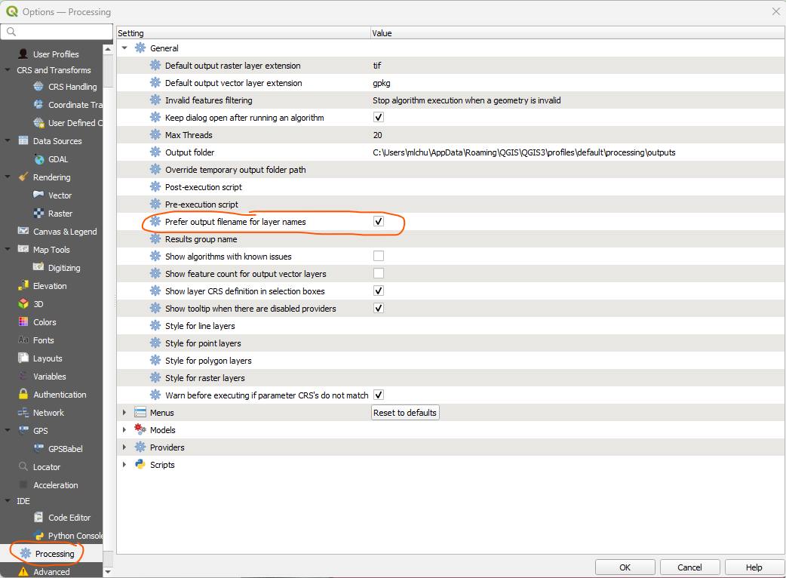
Figure 4. Checking the settings for output file name
2. From the main menu choose Vector – Geoprocessing Tools – Dissolve (Figure 5). The Dissolve window will open.

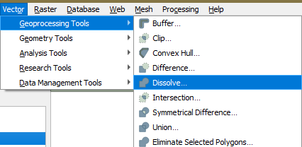
Figure 5. Using the Dissolve tool
3. On the Dissolve window, specify the following (Figure 6):
- Input layer: Choose the Census Tracts layer from the dropdown arrow.
- Dissolved: Click the Browse button and choose Save to GeoPackage. Navigate to lab5 folder and select the Bern_County.gpkg (same one you used before). The Save to GeoPackage window will open. Name the layer Bern_County.
- Make sure that the Open output file after running algorithm option is checked
- Run
- Close
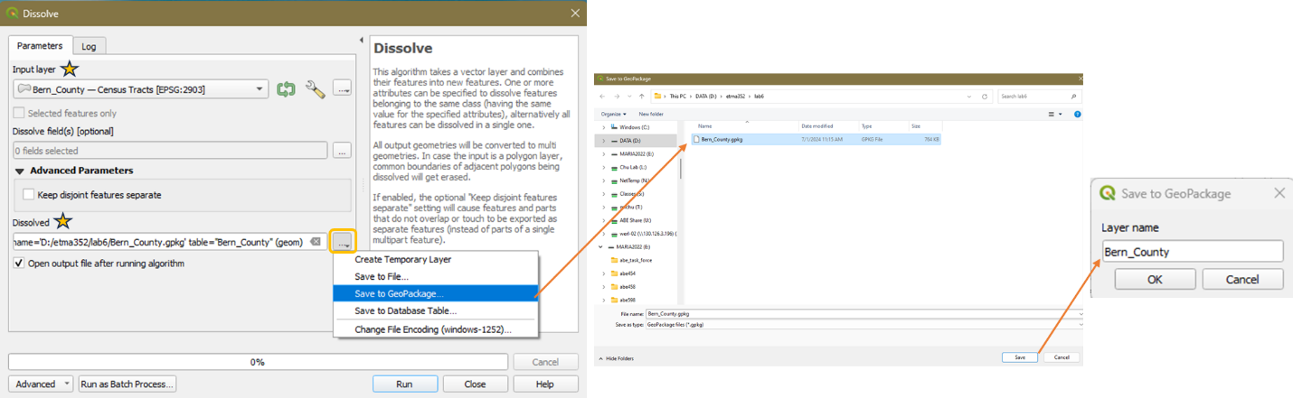
Figure 6. Dissolve toll settings
4. Now that you have the county boundary, you can remove the Bern_County – Census Tracts layer from the Layers panel.

5. Save your project!

1.3 Select the Monuments
You will want to filter the monuments that the surveyors are interested in. They sent you a list of requirements of what they want to see as follows:
- Elevation order = 1
- Last recovered on or after 1995
- Satellite observations were used for monument coordinate determination

The information relating to these requirements can be found in the attribute table in the following columns:
- ELEV_ORDER
- LAST_RECV
- SAT_USE

1. Double-click the Monuments layer to open the Layer Properties window. You can also right-click on the layer and then choose Properties.

2. Select the Source Tab (Figure 7A)

3. Find the Provide Feature Filter area (Figure 7A). This is where you can define the contents of the layer based on the attributes. It’s a way to filter a layer.

4. Click the Query Builder button (Figure 7A) to open the Query Builder window. Here you can write a SQL query to filter your data.

5. On the Query Builder (Figure 7B), all the attribute fields are listed in the Fields (left panel). Below are the Operators you can use to build your SQL expression. This expression will be written on the blank panel at the bottom. IMPORTANT: When building the expression, it is best to double-click the Fields and click the operators instead of typing them to avoid syntax errors.

6. Double-click on the field ELEV_ORDER. ELEV_ORDER will appear in the expression window enclosed by quotation marks. Attribute columns are always enclosed by “”.

7. Click the = sign under Operators to add it to the expression

8. On the right-side panel under Values, click the All button to see all the values in the ELEV_ORDER column

9. Double-click 1. The expression now read “ELEV_ORDER” = ‘1’

10. Add the next requirement to the expression by clicking AND under Operators

11. After the AND operator you will create the portion of the expression dealing with LAST_RECV >= 1995. Click the All button under Values and scroll to find1995. Since it does not exist, look for the date before 1995. That should be 19941012. The adjusted expression will then be LAST_RECV > 19941012. Create that part of the expression after AND

12. Add another AND operator and create the third portion of the expression dealing with the SAT_USE

13. The final expression is shown in Figure 7B.

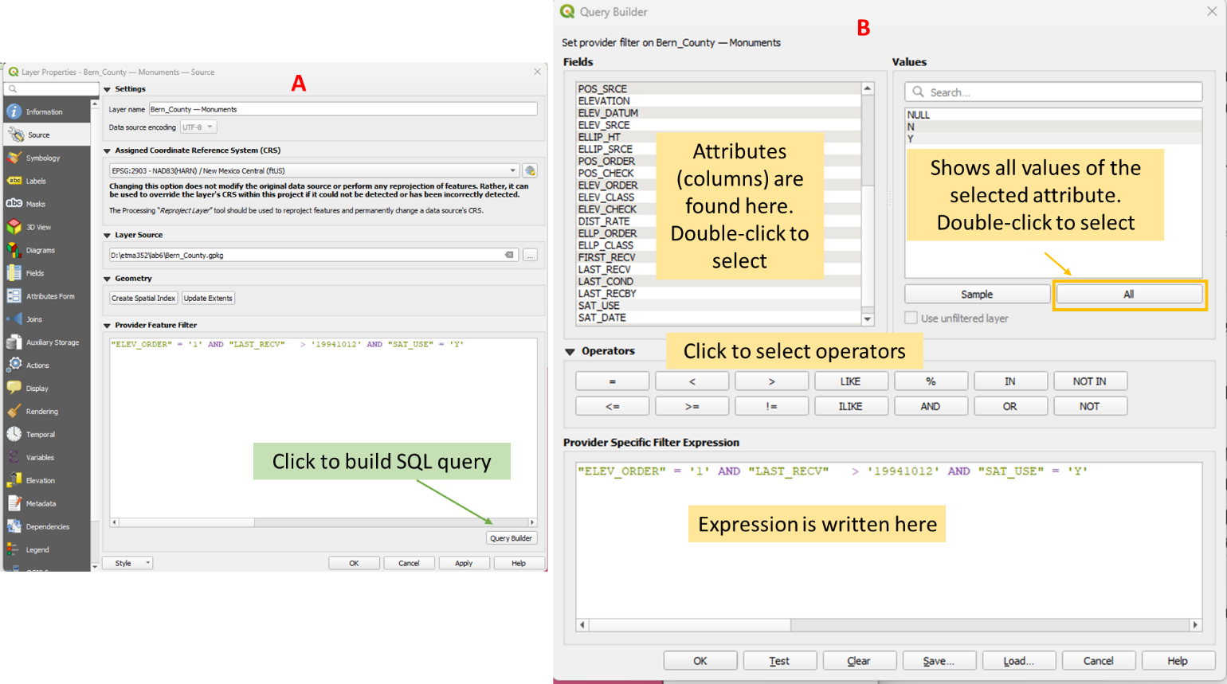
Figure 7. Building the SQL expression

14. Click OK to close the Query Builder window and OK to close the Layer Properties window.

15. The Monuments layer will show the monuments (dots) that satisfy the three requirements set by the surveyors. The layer will look something like in Figure 8

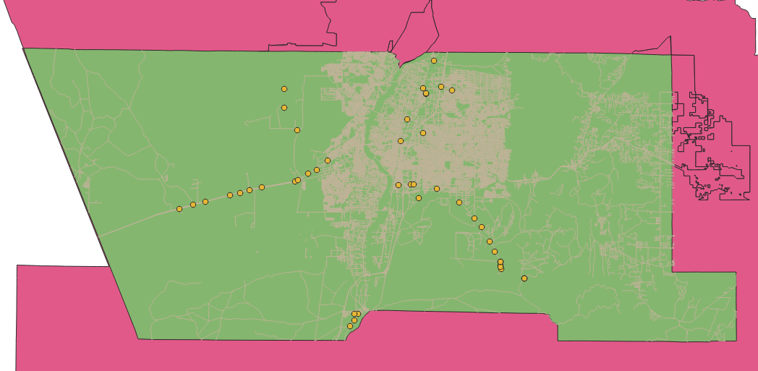
Figure 8. Monuments that satisfy the three requirements.
16. Right-click on the Monuments layer and choose Open Attribute Table. Verify that there are now 47 filtered features (see on top of the table or scroll down to see the number of rows). The attribute table now only contains the monuments that satisfy the requirements of the surveyors.

17. Save your project!

Part 2 – Buffering and Clipping Data

Now that you have prepared the county boundary and the monument layers, you will identify just the monuments within the Albuquerque City limits. First, you will create a filter on the jurisdiction and the RoadInventory layers as you did for the Monuments.

1. Open the attribute table of the jurisdiction layer. The first field (column), JURISDICTI contains the city names. Notice that the majority consists of unincorporated areas. You can click on the field header, and you will see a small arrow appear. Clicking allows you can toggle back and forth between ascending and descending sort of the record, making it easier to find values. Close the table.

2. Right-click on the jurisdiction layer and choose Properties then the Source tab. Open the Query Builder.

3. As you did with the Monuments layer, use the Query Builder to write an expression where JURISDICTI equals Albuquerque. This expression will only consider the city of Albuquerque and will filter out the other cities in the jurisdiction layer.

4. In the Layers panel, drag the jurisdiction layer above the Bern_County layer and uncheck the RoadInventory layer. Your map should resemble the one in Figure 9.

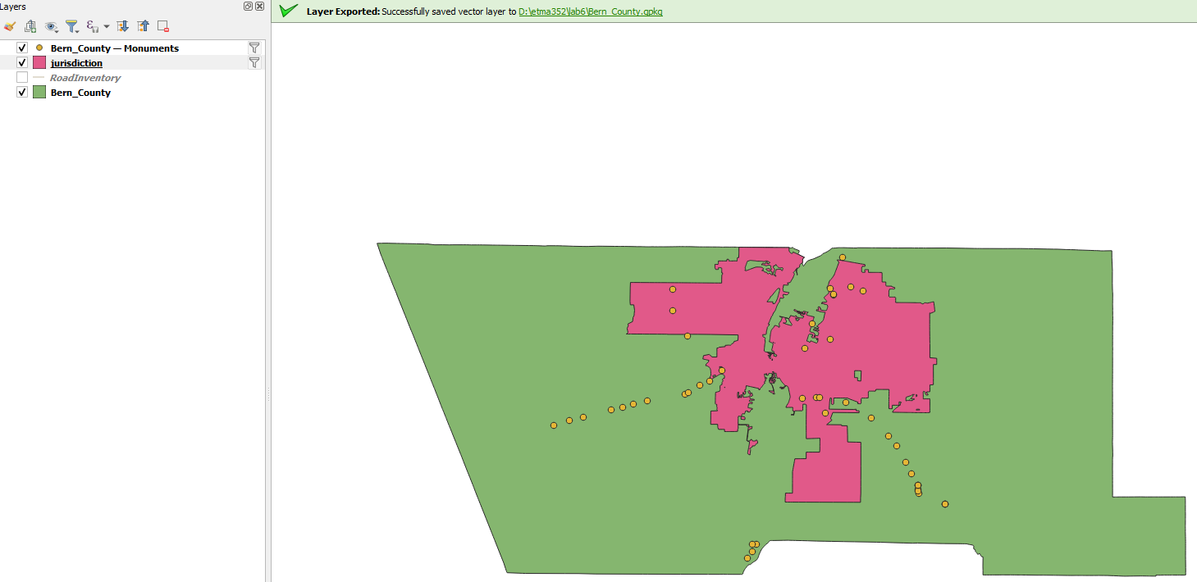
Figure 9. Map with filtered jurisdiction layer
5. In the Layers panel, enable the RoadInventory layer and open the attribute table. There is a lot of information in this layer. So far you have filtered a layer within QGIS but left the data on the disk the same. This time you will select the major roads and save them in a new layer in GeoPackage. Close the table.

6. Select the (click) the RoadInventory layer in the Layers Panel. On the top toolbars, click the dropdown arrow next to the Select Features by Value icon 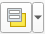 and choose Select Features by Values (Figure 10). The Select Features by Value tool allows you to search data by attribute interactively.

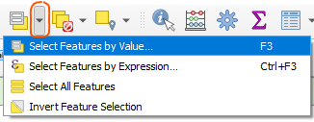
Figure 10. Select Features by Value button menu
7. In the Select Features window, scroll down to find the Class field. Type Major in the box.

8. The operator option on the right will switch to Contains. Click the drop-down menu and change it to Equal to (=) (Figure 11).

9. Click Flash Features and you will see all the major roads flash on the map canvas.

10. Click Select Features to select all major roads (Figure 11)

11. Close the window

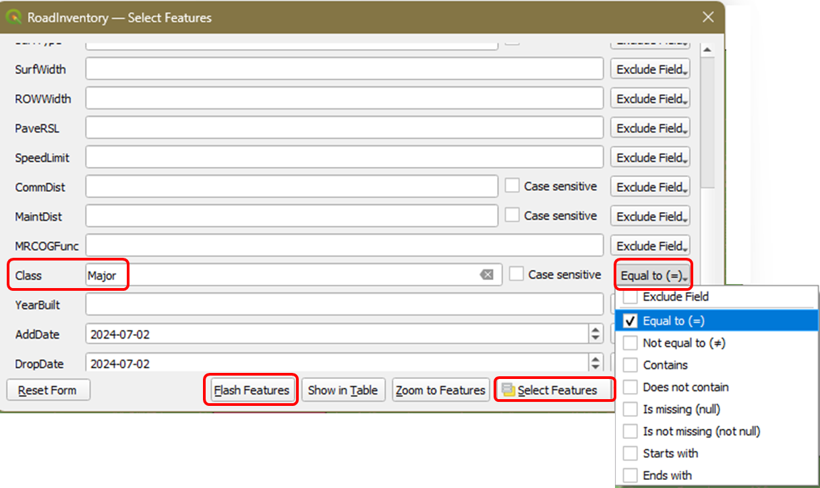
Figure 11. Select Features by Value
12. On the top toolbars, click the dropdown arrow next to the Open Attribute Table icon  and choose Open Attribute Table (Selected Features) (Figure 12)

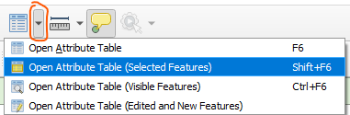
Figure 12. Open Attribute Table options menu
13. You should see that you have 4,593 out of 37,963 records selected (top of table). You can toggle between the form and table view by clicking the two icons at the lower right corner of the attribute table .

14. Close the table.

15. You will now export the selected set of records to your GeoPackage. Right-click on the RoadInventory layer and choose Export – Save Selected Features As (Figure 13).
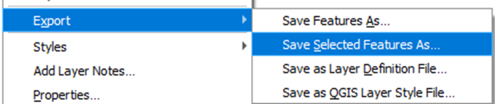
Figure 13. Export selected features
16. Provide the following information in the Save Vector Layer as window (Figure 14).
- Format: GeoPackage (default)
- File name: Click the Browse button and navigate to your lab5 folder and click Bern_County.gpkg. You will save it in the same GeoPackage as before.
- Layer name: Major_Roads
- CRS: EPSG:2903 - NAD(HARN)/New Mexico Central(ftUS)
- Make sure the Save only selected features option is checked
- Make sure the Add saved file to map option is checked.
- OK
- Remove the original RoadInventory layer from the Layers panel.

17. Save your project!

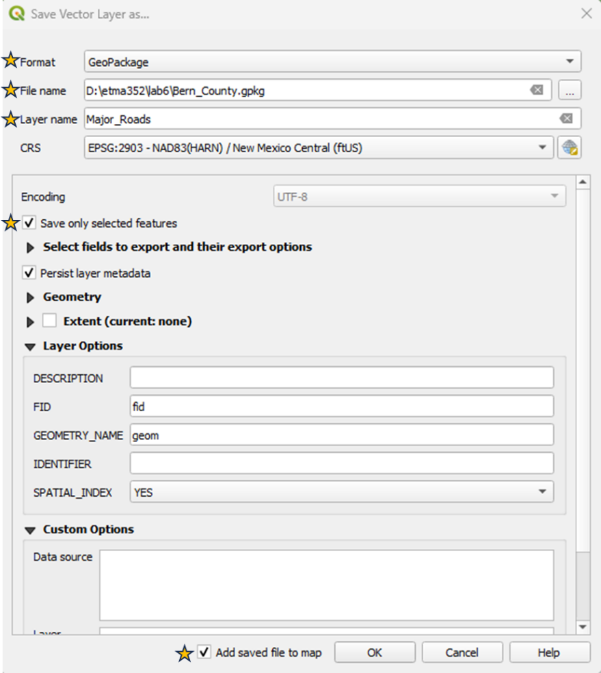
Figure 14. Saving selected records as a new GeoPackage layer
18. If you rearrange the layers in the Layers panel so that the Monuments is on top followed by the Major_Roads, jurisdiction, and the Bern_County boundary, your map should resemble Figure 15.

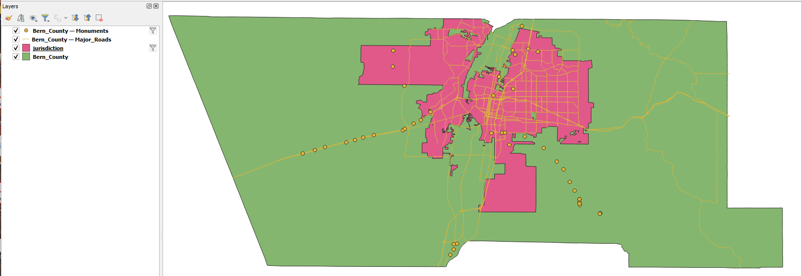
Figure 15. Resulting map from selected features.
Now that you have the Albuquerque City limits isolated, you will buffer Albuquerque by one mile. This will allow you to identify monuments that are either inside or close to the city limits. Buffer is an operation that creates a new polygon that is a buffer distance from another layer.

19. From the main menu choose Vector – Geoprocessing Tool – Buffer (Figure 16)

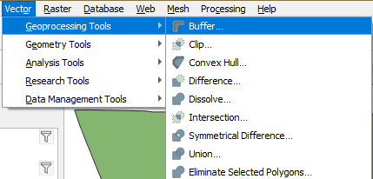
Figure 16. Buffering tool for Vectors
20. In the Buffer window, provide the following information (Figure 17):
- Input layer: jurisdiction, which now equals Albuquerque city boundary.
- Distance: 5290 feet. This is 1 mile but you want it in feet since the CRS is in feet.
- Segments: 20. This setting specifies the number of segments to approximate a quarter of a circle. Increasing it creates a smoother buffer.
- Buffered: Browse and Save to GeoPackage. Navigate to lab5 folder select the Bern_County.gpkg (same one you used before) and name the new layer Albuquerque_buffer.
- OK
- Run
- Close

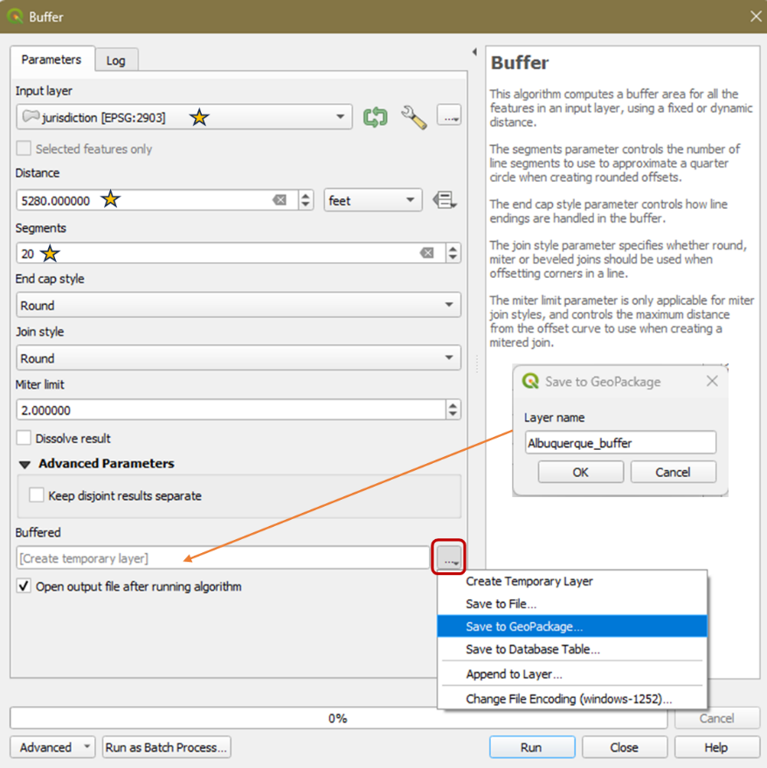
Figure 17. Buffer tool information

21. Drag the new layer (Albuquerque_buffer) beneath the jurisdiction layer to see the one-mile buffer of the boundary.

Now that you have the search area for the selected monuments, you will use the Clip tool to clip the Monuments layer to the Albuquerque_buffer layer. The Clip tool acts like a cookie cutter that cuts the data out from within the clipping boundary.

22. From the main menu choose Vector – Geoprocessing Tool – Clip (Figure 18)

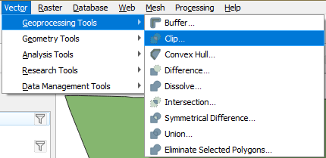
Figure 18. Clip tool for Vectors
23. In the Clip window, specify the following (Figure 19):
- Input layer: Monuments
- Overlay layer: Albuquerque_buffer
- Clipped: Browse and Save to GeoPackage. Navigate to lab5 folder select the Bern_County.gpkg (same one you used before) and name the new layer Albuquerque_monuments.
- Run
- Close

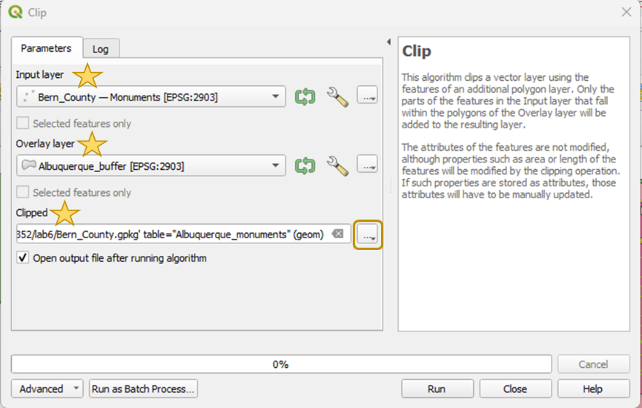
Figure 19. Clip tool information
24. Remove the Bern_County-Monuments layer from the Layers panel.

25. Save your project!

Part 3 – Preparing the final map.

3.1 Labeling the Monuments and Roads.
1. Click the Open Layer Styling panel icon

2. Styling the Albuquerque_monument layer.
- On the Layer Styling panel (right side) select the target layer as the Albuquerque_monuments (Figure 20)
- Click the Simple Marker and change the marker to a triangle. Choose the color that you want.

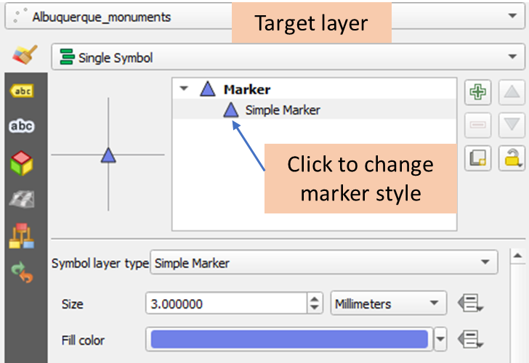
Figure 20. Styling the marker
- Click the Labels tab
- Change from No Labels to Single Labels
- Value: Click the dropdown arrow and choose FeatureID
- Format the labels using the tabs below the Value. Below are some tabs that you can use to make the labels look better.
  - Text tab- change the font
  - Placement tab- offsets the label from the marker

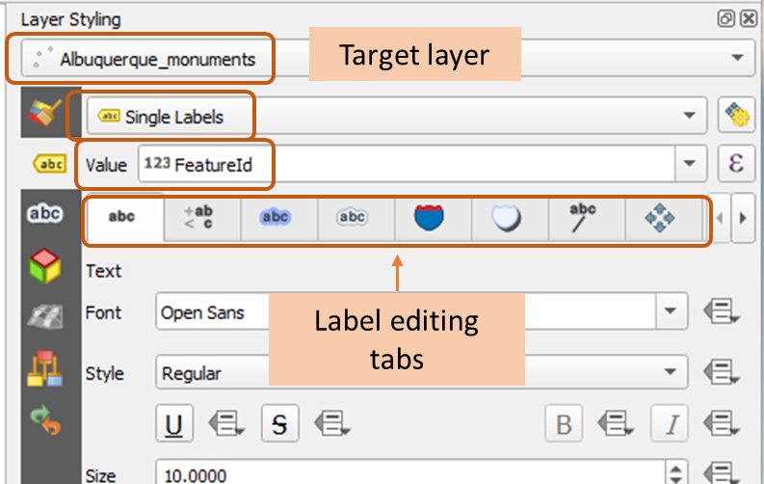
Figure 21. Styling the labels
3. Styling the Major_Roads layer.
- On the Layer Styling panel (right side) select the target layer as the Major_Roads
- Click the Labels tab
- Change from No Labels to Single Labels
- Value: Click the dropdown arrow and choose StreetName
- Change the font to size 5.25.

4. Change the style of the layers to make the map more attractive. Choose whatever color you prefer. You can also change the opacity of the buffer to make it look like a background (see Figure 22 as an example).

5. Save your project!

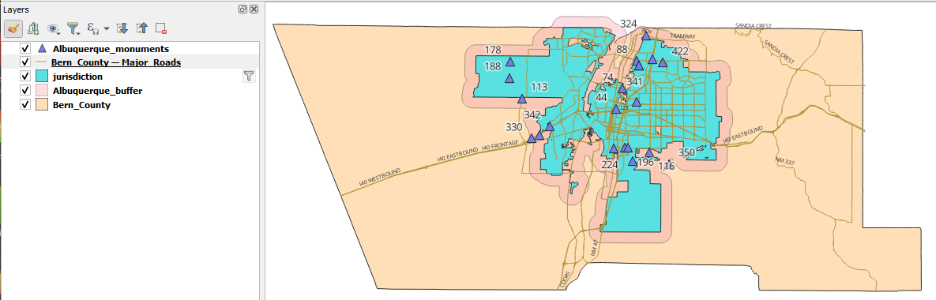
Figure 22. Example of the final map

3.2 Prepare the printable map

Your analysis produced a map that will help surveyors find the monuments. Hence the final printable map should show the major roads to give them idea of how to access the monuments.

1. Rename the layers in the Layer panel to (right click on the layer and choose Rename Layer:
- Albuquerque Monuments
- Major Roads
- City of Albuquerque
- One-mile buffer
- Bernalillo County

2. Right-click on the Albuquerque Monuments layer and choose Zoom to layer. This is the detail that you will show in your printable map.

3. Click the New Print Layout icon

4. Create a printable map with the following elements (see Figure 23 for an example):
- Page properties: Size = letter, Orientation = Landscape
- Title: Albuquerque Vertical Control Monuments
- Legend – remove the background by unchecking the Background option from the Legend panel (right panel of QGIS)
- Scale bar
- North arrow
- Your name and date

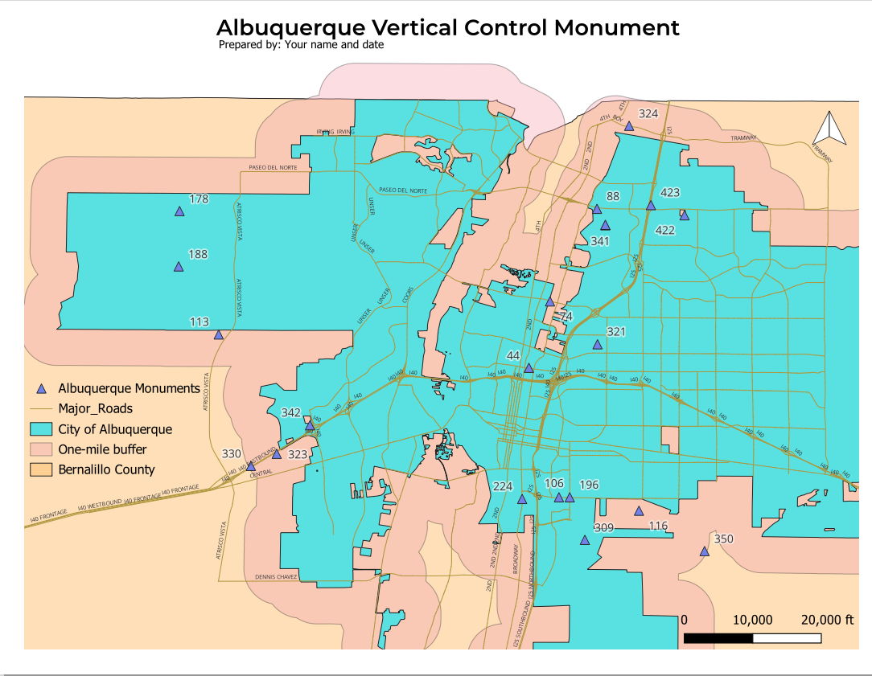
Figure 23. Example of the final printable map

4. Export your map as an image (*.PNG file, dpi = 300) and as a PDF file . Insert the image in your lab report and submit the pfd file along with your lab report on Canvas.

